**Purpose:**

This document is to set up SQL Server connection in Power BI

**Scope:**

This document applies to all data analysist and epidemiologist using Power BI through sql server connection.

**Materials:**

|  |  |
| --- | --- |
| File Name | Location |
| Server name | DSPV-INFC-1601\QSRV1 |
| Database name | OADC_DATALAKE |
| Power BI Workspace | TBD |
| SQL Query | SELECT MetricDate, ReportURL, SUM(Bounces) as TotalBounces    FROM [OADC_DATALAKE].[Adobe].[bounces]      WHERE PageURL LIKE '%communityguide%'  AND MetricYear = '2024'  GROUP BY MetricDate, ReportURL  ORDER BY ReportURL, MetricDate |

**Prerequisites**:

* Must have Power BI Desktop
* Must have permission to use Community Group WCMS SQL Server

**Process:**

1. Open Power BI Desktop

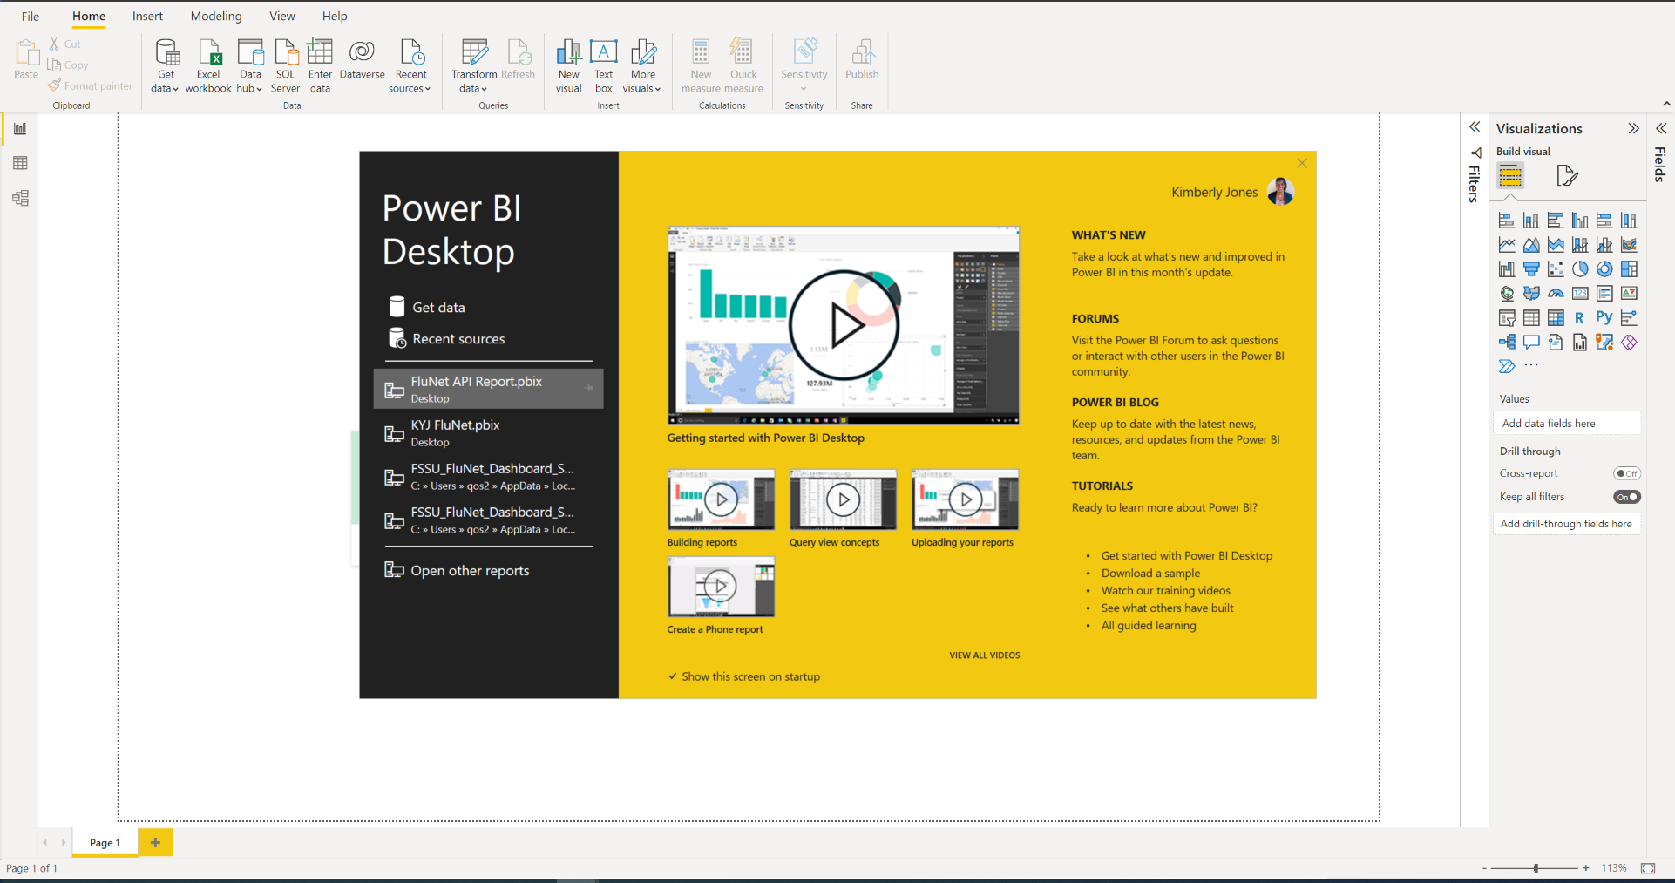

1. Click Get data

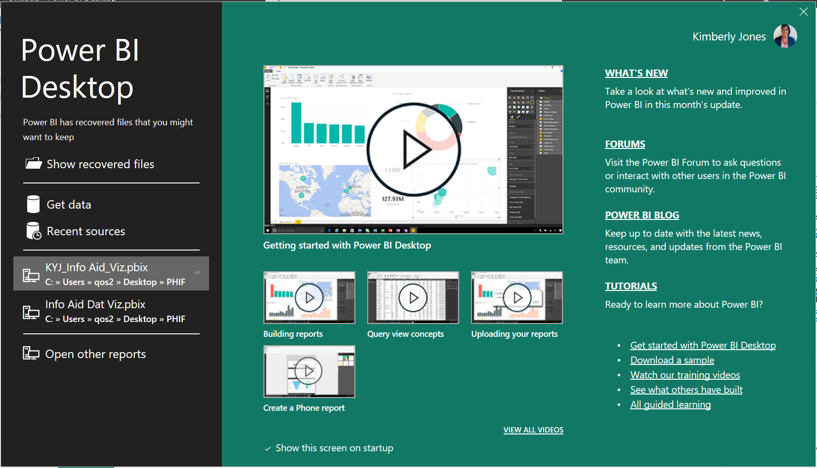

1. Search “Azure” > Select Azure SQL database

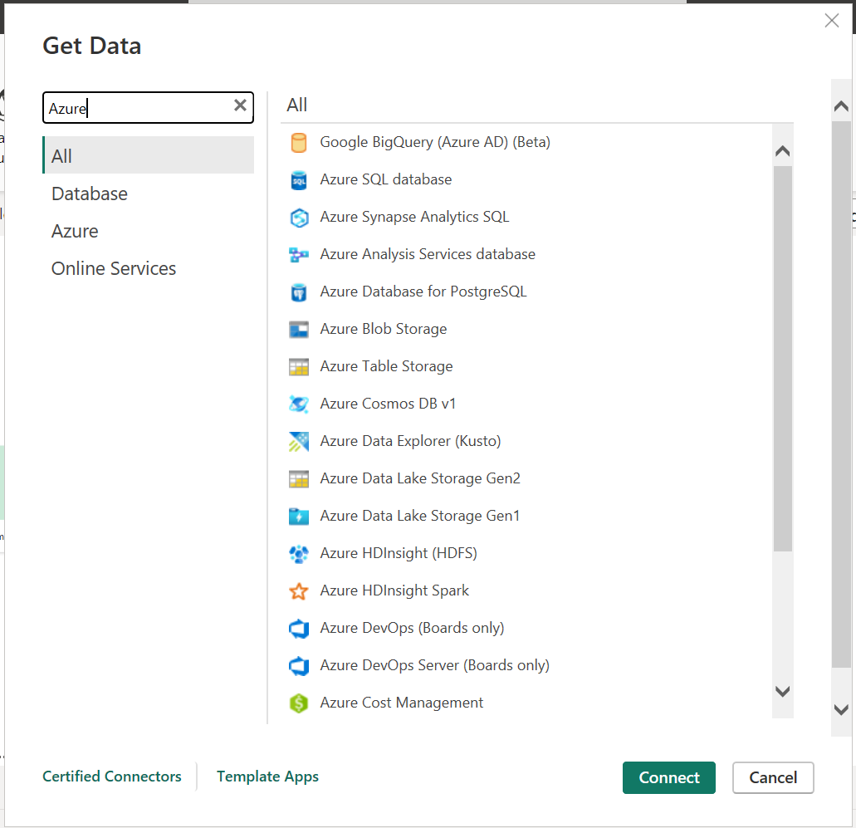

1. Click Connect
2. Add Server and Database names
   1. Server name:
   2. Database name:
3. Click “OK”

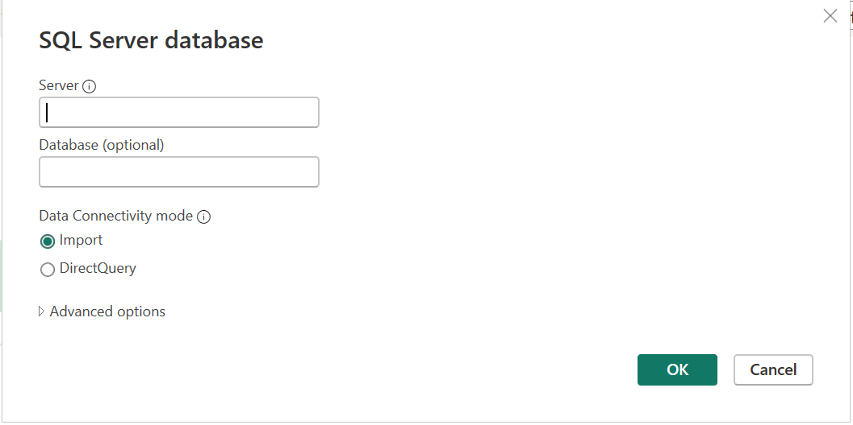

1. Power Query Editor will open to allow for edits

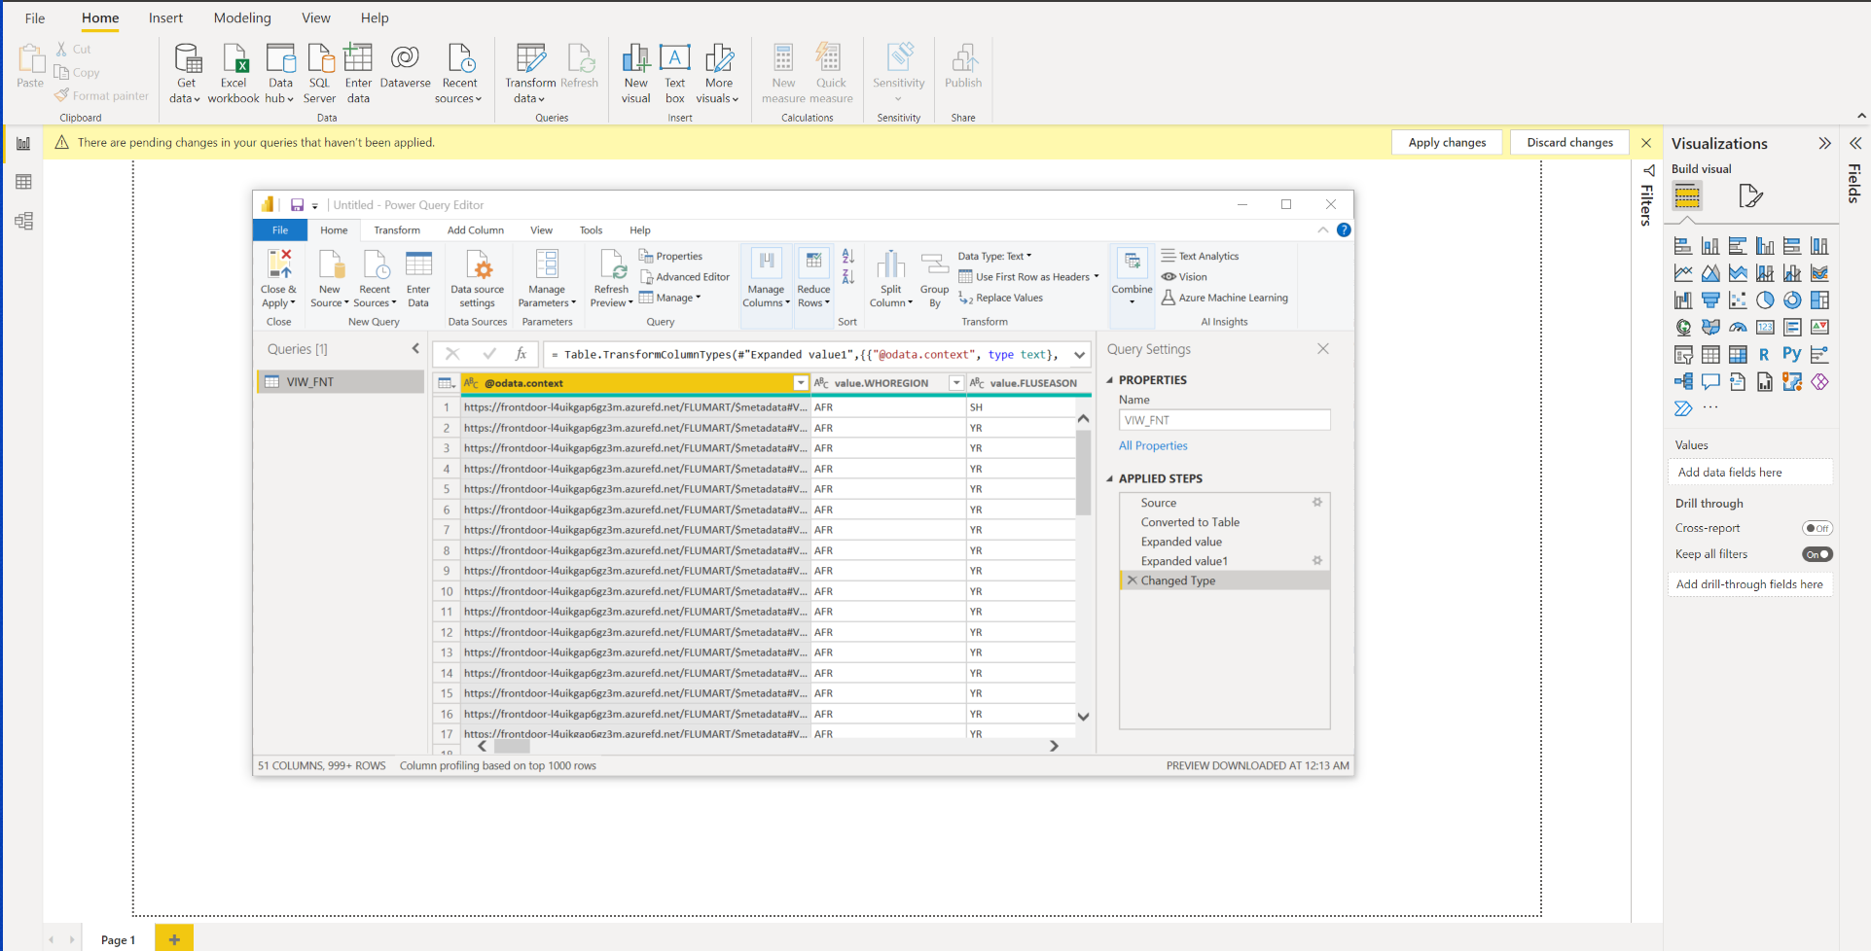

1. As you make changes you will see the changes in the right pane labeled “Applied Steps”
   1. If you have made an error click on the x next to the step to remove and start over

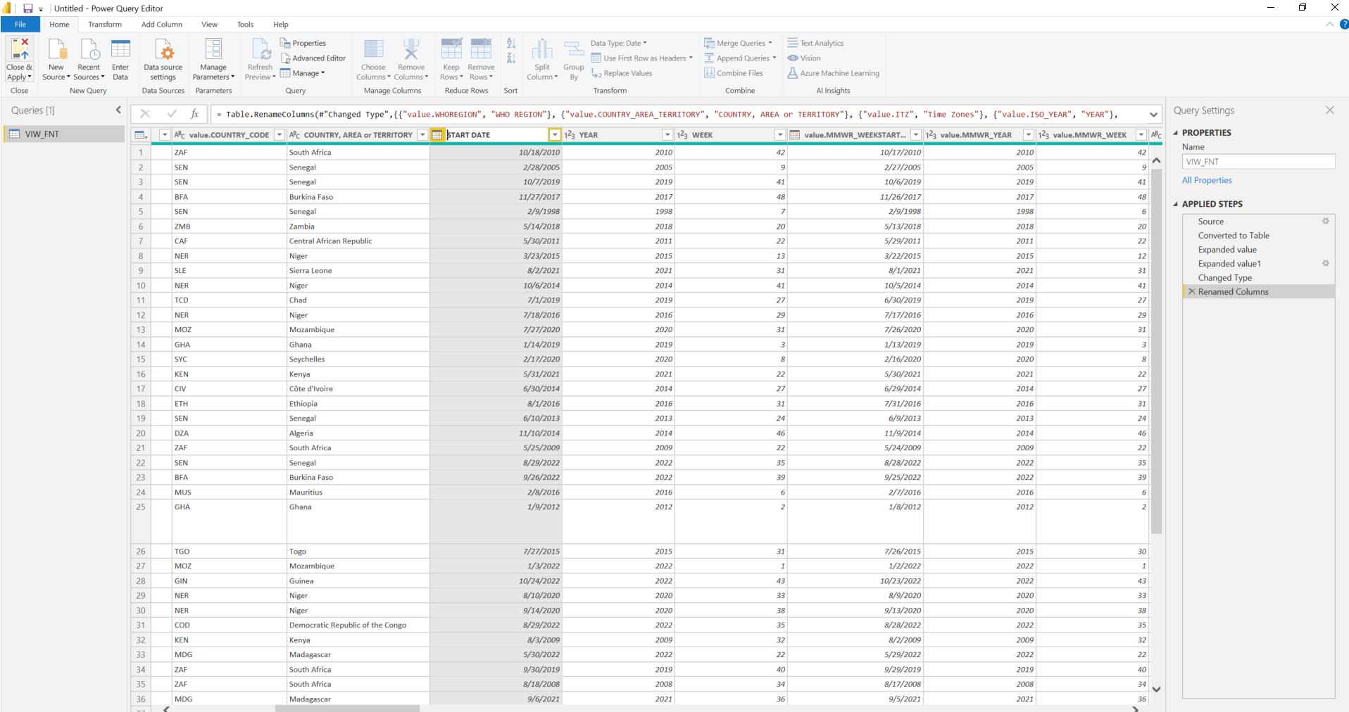

1. Click Close and Apply (Top right corner)
2. Power BI will upload and apply the changes

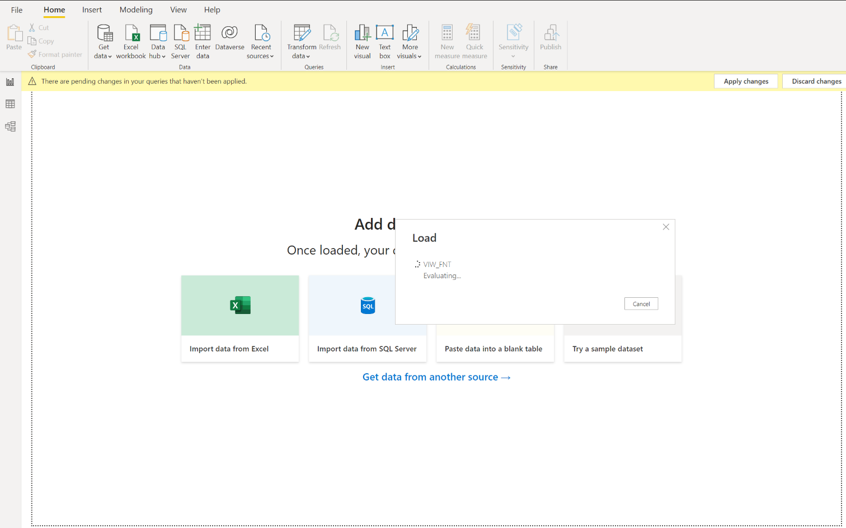

1. Click on the Report icon to the left of the screen
   1. Data will show on the right side of the screen to begin using for your models

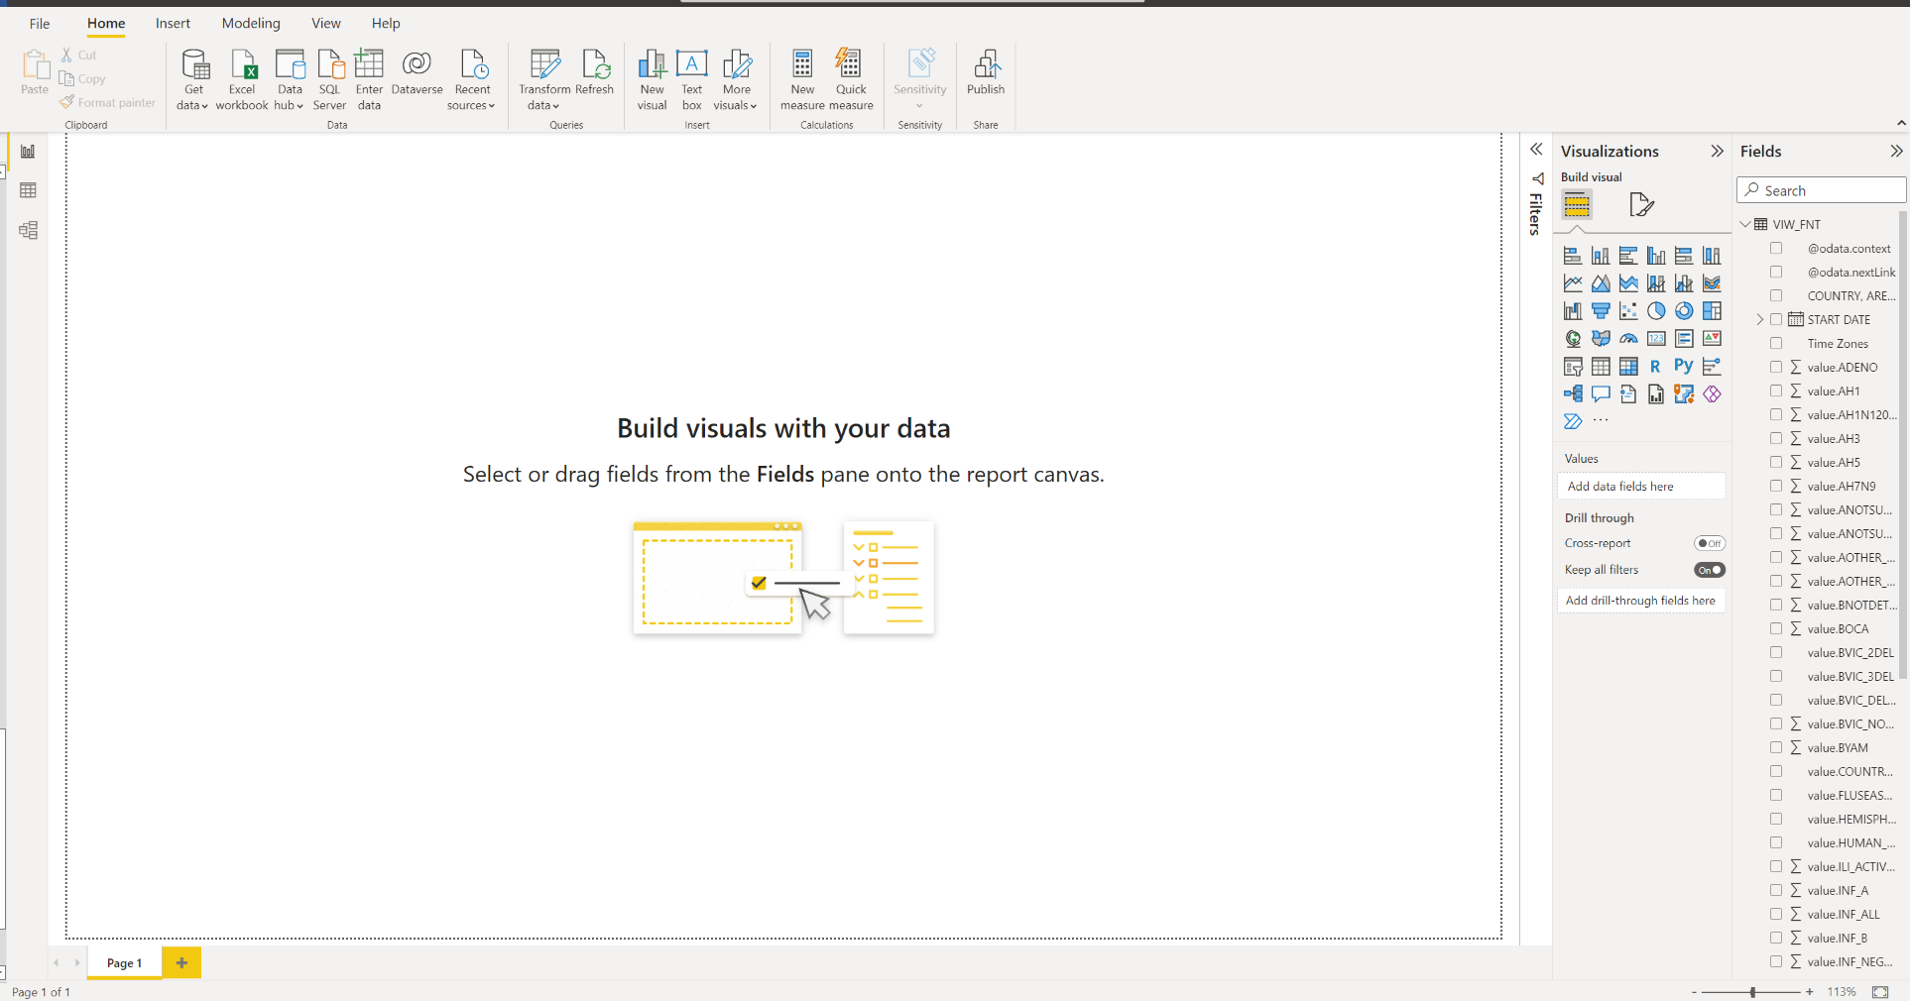

1. Click Publish

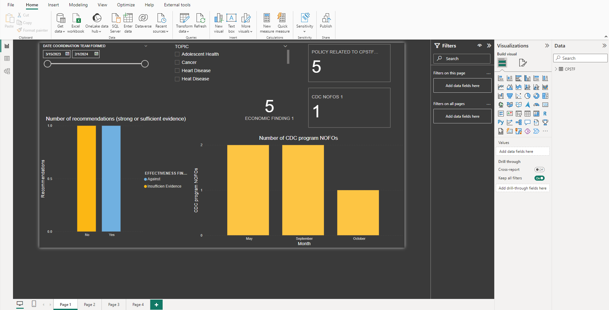

1. Select location to Publish
   1. OSER Sharepont Site??

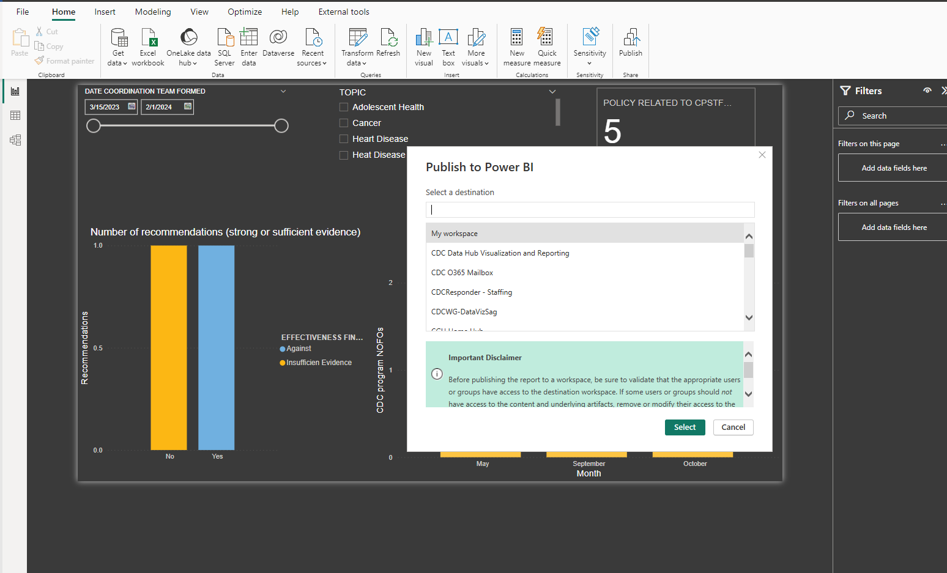

1. Select the blue hyper link

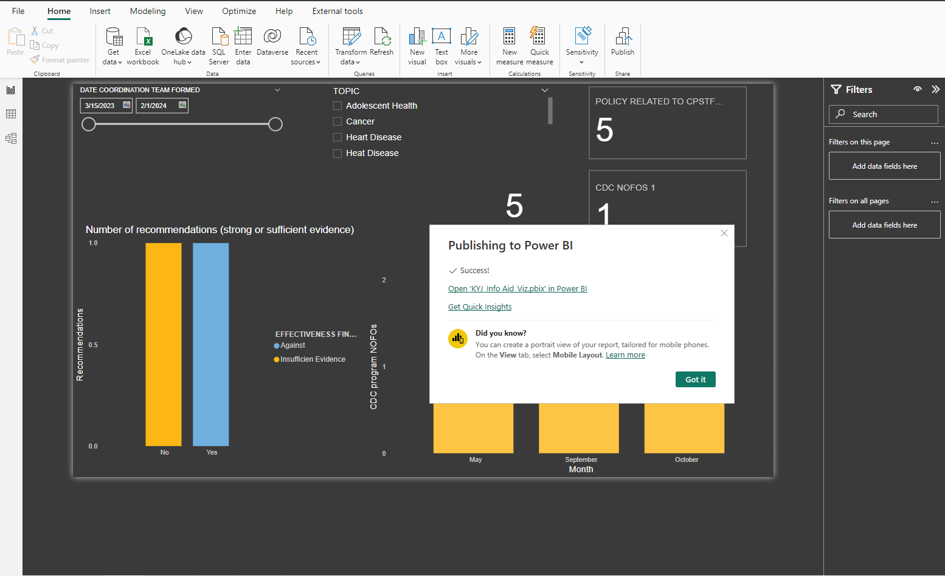

1. You land within Sharepoint workspace to view and edit reports

